Why volunteer?
What do you think when you hear the word volunteering?
You don’t do anything worthwhile
You don’t get paid!
Old
Boring

However, did you know that voluntary work can improve your university, apprenticeship or job application? You can gain so many different skills from volunteering which will enhance any application or interview by referring to situations, outcomes which can make you stand out to an employer. Volunteering has changed in recent years to being more inclusive, exciting, rewarding and supportive in your future career.

Volunteering is very similar to work experience. It requires little previous experience and gives you the flexibility to fit it around your studies and life making it ideal for sixth form students. There are opportunities in more career areas than you might expect or get an insight into working with a variety of different people and roles. Volunteering also has the ability to fit into a schoolwork schedule either over the weekend, after school or during school holidays. Remember to think about your time commitments carefully, for example are you able to dedicate a few hours a week, every week for 6 months or just during the summer holidays. Volunteering can also enable you to get that all important reference, especially if you are a committed member.

In this current climate, there are plenty of volunteering opportunities which are local and in accordance with social distancing guidelines, can even be done remotely at home. Make sure you always evaluate any risks before making a commitment and whether you have the capacity that suits your lifestyle.

I’m not sure what I want to do as a career? ...No problem!

Volunteering helps you to build confidence and develop skills which you can use in any career. Additionally, if you have a path in mind why not build on some of the personal skills you might need for the role:
- Support by writing blogs - thinking of heading into publishing or marketing, adding information to your linkedin page
- Support a local Scout, Guide, Cadets group - working with younger children, or gaining a certificate in first aid, help with fundraising
- Volunteer at an animal shelter- working with animals, communications
- Volunteer in a Charity Shop - helping your local community, varying your communications in a retail setting
- Possibly volunteering at School- e.g. maybe children at your school might need help (ask your teachers),after school clubs, DoE, mentoring, starting a club, reading with young students

How to find volunteering work?

There are several places, which offer local or London borough-based opportunities, inputting how little or far, you wish to travel and choosing the right opportunity that works best for you:

- Websites such as Do it, Volunteering matters , Team London and vinspired
- The National Charity Service specialises in opportunities for 16-17 year olds and is currently recruiting Charity Shop volunteers- NCS
- Local newspapers and websites such as Newham Recorder or some boroughs have Volunteering centres e.g. www.newham.gov.uk/VoluntarySectorOrganisations, Volunteer Centre Croydon, Volunteer Centre Islington, Volunteer centre Southwark, METRO Lewisham. Check in on any organisations you might be interested in, make sure you look carefully at the age limit as some volunteering will only allow 18-year olds to take part e.g Red Cross, Samaritans

In volunteering noting down what you gain from volunteering will make it easier for you when the time comes to begin an application, and help you remember more detail in case you’re asked about your volunteering at an interview.
Note down any transferable skills:

- Time management (Super important!)
- Problem solving
- Communication
- Prioritisation
- Examples of being creative in a difficult situation
- Difficult situations – what did you do? What was your input?
- Training other volunteers
- Understanding more about the world of work
- Working well under pressure

Remember these are crucial when being interviewed as you can draw on real life situations and convince recruiters or universities you have what they are looking for.
Most importantly have fun and enjoy volunteering… ask your teachers or parents what their thoughts are! Remember the world post-Covid might look very different, therefore most employers or universities might ask the key question, what did you do during lockdown?….amaze them!!

Read about the benefits of volunteering here: https://www.london.gov.uk/city-hall-blog/volunteering-student-gave-me-chance-see-real-world

Access All Areas

Date and time: 1st July/ 4pm on Zoom
Talk with Parvin Minhas
Role: Senior Policy Officer (Office for the Security and Counter Terrorism)
Home Office- Civil Service

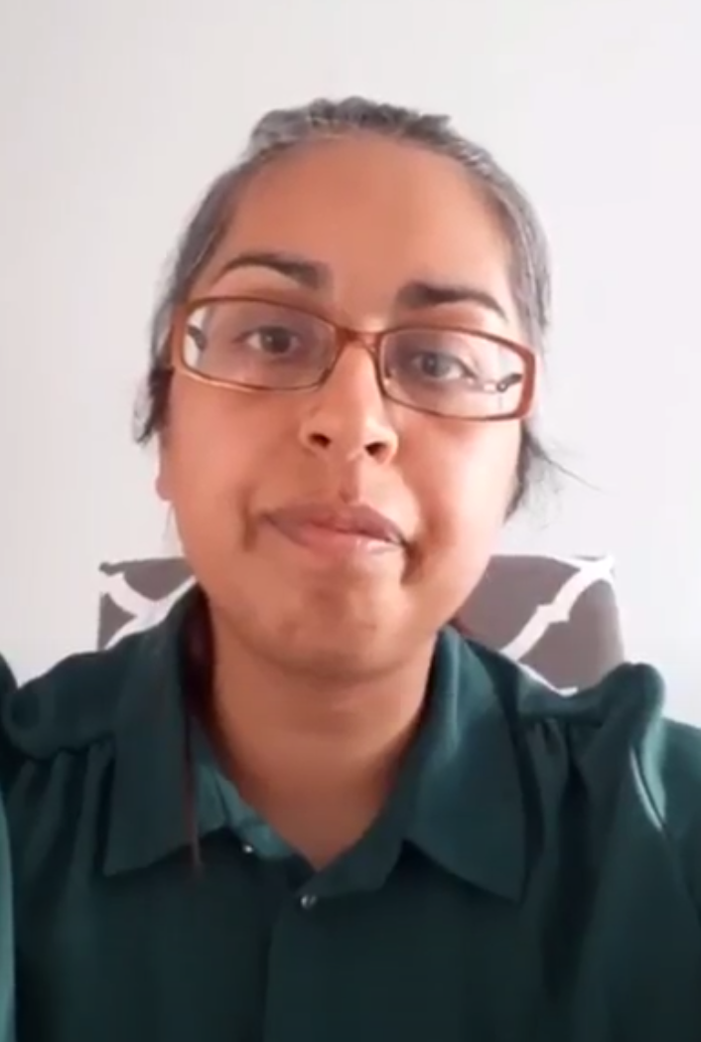

Date and time: 2nd July/ 4pm on Zoom
Talk with Elizabeth Levett
Role: Press Officer for the Bank of England
Bank of England- Finance

- Please make sure students have signed up to Access Aspiration as they will not receive these sessions if that have not registered and will not be given access if they are not added on the list for safeguarding purposes.
- Please arrive to the session on time (Via zoom- you will be placed in a waiting room until we are ready to start). Any late entries might not be permitted.
- When admitted to the Zoom session, please turn off your camera and place yourself on mute.
- Please make sure you have your full name when logging in to Zoom.
- Please have any questions ready to ask the business professionals.

The Home Office is the lead government department for immigration and passports, drugs policy, crime, fire, counter-terrorism and police.
Please click on the link for more information: https://www.gov.uk/government/organisations/home-office/about

Parvin’s career began in the charity sector, where she worked for 2 years arranging British Sign Language interpreter bookings
She joined the Home Office in 2003 and have since worked in several different roles, expanding her knowledge and contributing to the various areas within the department.

Parvin in works as a Senior Policy officer.
Working in the Press Office at the Bank of England, I have responsibility for banknotes, statistics, research and support on our monetary policy communications. I worked heavily on The New Fiver campaign and then devised and implemented the communication strategy for the new £10 note featuring Jane Austen. I work closely with the Chief Cashier and advise on messaging and public engagements.

Elizabeth has worked for the Bank for England for almost 7 years.
Have started of working as an Economist. Emma worked in the Demand and Supply Issues team within Monetary Analysis where she specialised in the UK Housing Market. Her work focused on analysing current trends and housing market data as well as producing forecasts for relevant variables. Elizabeth also look at issues around household behaviour, in particular by analysing micro data from surveys.

