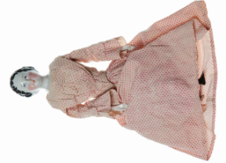 Childhood

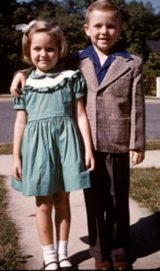Half-Term Project

1. **Design your own 1950s party outfit. Remember lots of clothes from the 1950s were hand made so you could use some material and get your adult to help you sew the material together like we did in our DT lesson.**

Our topic for this half term has been Childhood.

These activities are for you to do at home with an adult. You can do all of them or choose the ones that you find most interesting.

Your project is due by **Friday 13th January 2023.**

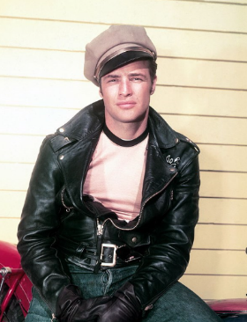

**2. Queen Elizabeth II was crowned in 1953. Design your own crown for the coronation. Let your creative side out and have fun!**

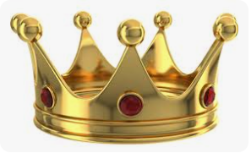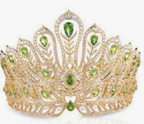

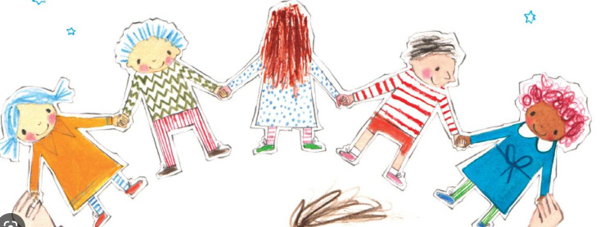

**3. With adult supervision, can you write a story about the journey you would take with your own paper dolls. Remember to give them all names. Who would you meet on your journey? Where will you end up visiting?**

**4. With your adult, can you find some pictures online to show what the area you live in looked like in the 1950s? Can you see any similarities and differences?**

