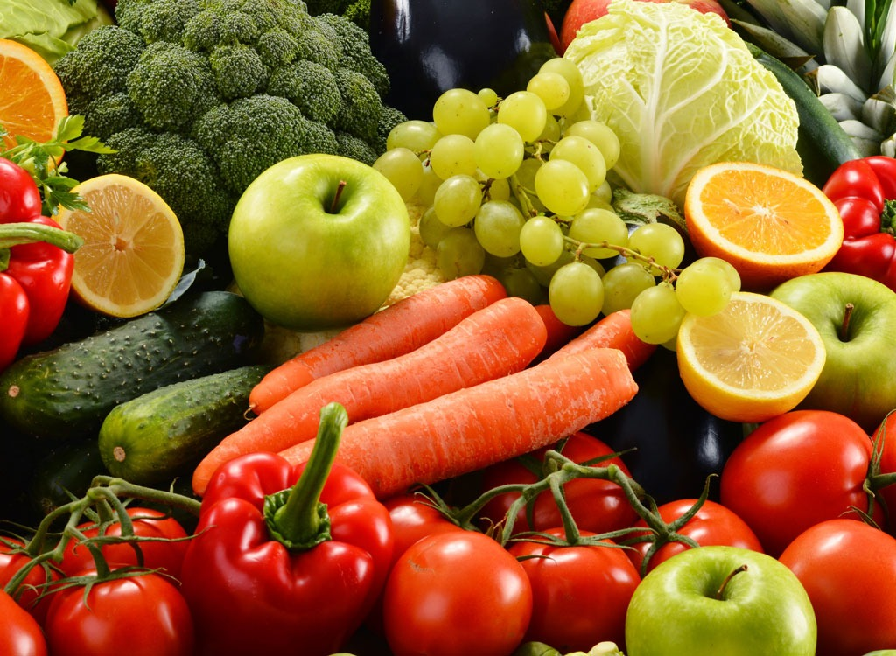

This half term we have been learning about the importance of nutrition for humans and other animals. We have also learned about what the role of the skeleton and muscles are. Below are your homework projects. Please choose at least one to be completed and brought back to school by **Friday 13th January 2023**.

**Cooking**

Cook or bake a dish at home with your family. Write out the list of ingredients needed and the instructions to create your meal. Bring in a picture if you can so we can see what you made!

**Poster**

Use a range of sources to find out about the role and functions of the skeleton. Use your research to create an information poster about the different parts of the skeleton. Include images to make your information poster interesting.

**Detailed illustration**

Eating a balanced diet is an important part of maintaining good health, and can make you feel your best. Use the internet and information books to find out more about what a balanced diet looks like. Use your existing knowledge and research to draw a detailed illustration of an Eatwell plate and write a short paragraph to describe each part of the plate i.e. carbohydrates, proteins, fruits and vegetable, fats, dairy.

**Through the Ages**