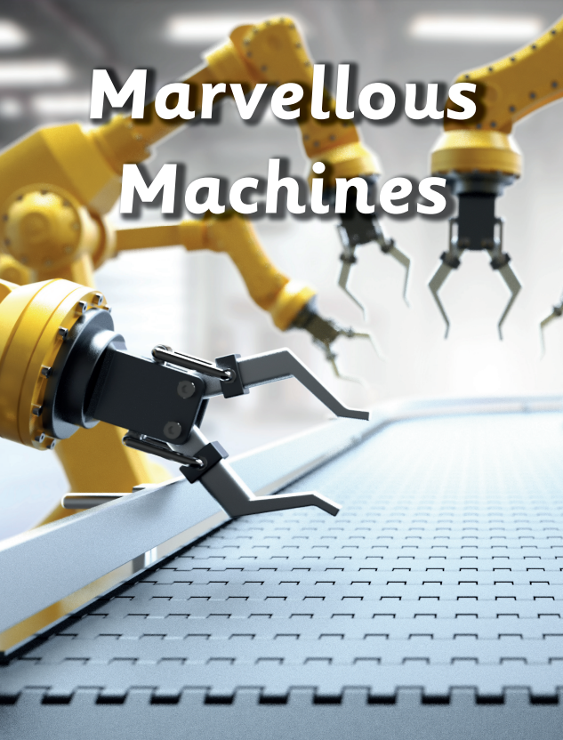

This half term we focused on machines in our topic ‘Marvellous Machines’. We looked at different machines and how they help us in our everyday lives. Choose at least one of these projects to complete and bring back to school by **Friday 13th January 2023**.

1. Vehicles are a type of machine. Use junk modelling materials to create your own vehicle.
2. Think about the machines you use every day and how they help you. Imagine that you could design a machine to do a job. What job would you like your machine to do and how would you like it to look? Draw a picture of your own machine and label it.
3. Go on a machine hunt around your home. What did you find? What does it do? Draw a picture of the machines you found, and write a little bit about them.