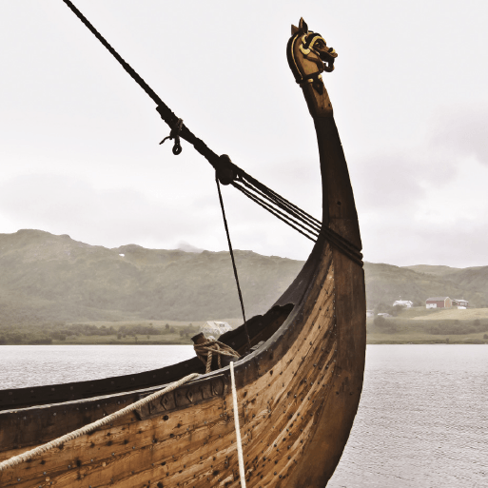

**Invasion**

Use the internet to search for pictures of the artefacts found at the Sutton Hoo burial site, such as The Franks casket, purse lid and shoulder clasp. Create a piece of Anglo-Saxon art using the designs on the artefacts as inspiration.

Use a range of resources to create a knowledge organiser about the Battle of Hastings. Include details about key dates, people and events and a paragraph to explain why this battle was so significant for England.

Imagine you are an Anglo-Saxon invader. Write a letter home to your family in Denmark, the Netherlands or Germany. Include details about the journey to England, where you have settled and explain any difficulties you have faced.

Use a range of historical source materials to research what everyday life was like in Anglo-Saxon or Viking Britain. Areas to research might include clothing, housing, food, culture and religion. Create a non-chronological report, blog or presentation to present your findings.

This term, our topic has been ‘Invasion’ and

we have been learning all about the Anglo Saxons, Vikings and Normans.

Below are your home learning activities for our topic.

Please choose at least 1 activity to complete by **Friday 13th January 2023**.