**Planned School Closure**

Dear Parents and Carers,

Due to the predicted adverse weather conditions for later tonight and tomorrow morning Riverside Primary School will be closed on Friday 2nd March 2018.

Please continue to check the Primary School website and our Twitter page, @RVSPrimary for further updates.

Yours sincerely,

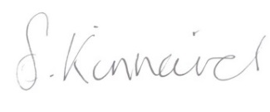

Mrs Sarah Kinnaird

Head Teacher