Impact of Primary PE and Sports Premium funding at Riverside Bridge School

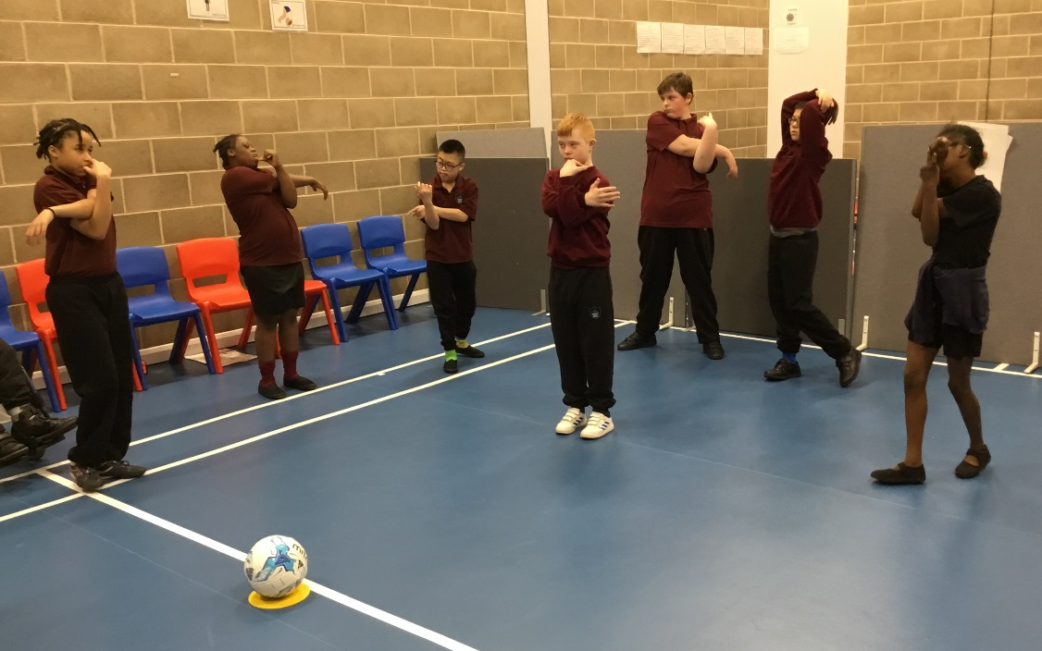
Key achievements to date: | Areas for further improvement and baseline evidence of need:
All children are making steady progress in PE. Their skills are improving and the children are given the opportunity to develop and practice the skills taught during break and lunch times with equipment provided.  All children have access to 3 x 45 minutes sessions of PE per week. As many of our children are motivated by food, this is enabling us to help combat the risk of obesity. | As a new and expanding school we are currently increasing our equipment stores for both the PE department and the break and lunchtime experiences. More equipment needs to be available to extend key skills and improve the opportunities to children dependent on the topics taught. Students to begin accessing swimming lessons.

Meeting national curriculum requirements for swimming and water safety | Please complete all of the below*:
What percentage of your current Year 6 cohort swim competently, confidently and proficiently over a distance of at least 25 metres? | 0%
What percentage of your current Year 6 cohort use a range of strokes effectively [for example, front crawl, backstroke and breaststroke]? | 0%
What percentage of your current Year 6 cohort perform safe self-rescue in different water-based situations? | 0%
Schools can choose to use the Primary PE and Sport Premium to provide additional provision for swimming but this must be for activity over and above the national curriculum requirements. Have you used it in this way? | Yes/No
*Schools may wish to provide this information in April, just before the publication deadline.

Academic Year: 2017/18 | Total fund allocated: £9532 | Date Updated: March 2018
Key indicator 1: The engagement of all pupils in regular physical activity – Chief Medical Officer guidelines recommend that primary school children undertake at least 30 minutes of physical activity a day in school
School focus with clarity on intended impact on pupils: | Actions to achieve: | Funding allocated: | Evidence and impact: | Sustainability and suggested next steps:
All children to receive 3 x 45 minute PE sessions  Sports extra-curricular clubs offered to all children  Increase pupils activity levels during break and lunchtimes  School sports day | Specialized PE Teachers to deliver outstanding lessons  1 Lesson per week is a competitive sport, 2 lessons are skills focused  PE teachers to deliver 2 after school clubs per week, including healthy snack and refreshment  Footballs and equipment provided during break and lunchtimes  Equipment and healthy refreshments provided for all children | £5000  £150  £1000  £500 | Children are showing progress in the PE skills  Some children have taken part in competitive competition  More children are beginning to access after school clubs  All children have the opportunity to become active during their school day and combat the effects of ‘motivation by food’  Healthy refreshments for all children | Children to continue to access PE sessions  Expand contacts for further competitive sports  Continue to offer after school clubs  Provide equipment for the playground depending on the skills taught within PE lessons  All children have the opportunity to make healthier choices
Key indicator 2: The profile of PE and sport being raised across the school as a tool for whole school improvement |  |  |  | Percentage of total allocation:
 |  |  |  | %
School focus with clarity on intended impact on pupils: | Actions to achieve: | Funding allocated: | Evidence and impact: | Sustainability and suggested next steps:
Introducing PE/physical activity within cross curricular lessons | PE teacher & Upper phase leader attend Active literacy course to introduce more activity into core lessons | £500 (cover) | Children become more active through their school day | Continue to develop literacy curriculum to include more active sessions

Key indicator 3: Increased confidence, knowledge and skills of all staff in teaching PE and sport |  |  |  | Percentage of total allocation:
 |  |  |  | %
School focus with clarity on intended  impact on pupils: | Actions to achieve: | Funding  allocated: | Evidence and impact: | Sustainability and suggested  next steps:
To develop and maintain staff confidence in PE | PE teachers to attend borough run courses  PE teachers to deliver CPD sessions termly to all staff  PE Teacher to attend outstanding link schools to maintain consistent high quality teaching and ideas  All class teachers to introduce active sessions within their school day | £500 (cover)  £200 (Co-Ed overtime)  £500 (cover)  £0 | Specialist teachers knowledge grow and keep up to date  Knowledge disseminated across the school  Continued high level of lessons being delivered  All children have the opportunity to become active during their school day and combat the effects of ‘motivation by food’ | Up to date strategies  Continued CPD sessions for all staff  Monitored through quality of teaching and pupils data  Continued active sessions
Key indicator 4: Broader experience of a range of sports and activities offered to all pupils |  |  |  | Percentage of total allocation:
 |  |  |  | %
School focus with clarity on intended  impact on pupils: | Actions to achieve: | Funding  allocated: | Evidence and impact: | Sustainability and suggested  next steps:
Pupils have the opportunity to experience a range of sports outside of the curriculum including experience events | Sports relief day  Children experience outdoor pursuit center (Stubbers) | £20  £1000 | Children have taken pride in representing their school and have received adulation during assemblies for their participation | Continue to provide experience events for children to attend
Key indicator 5: Increased participation in competitive sport |  |  |  | Percentage of total allocation:
 |  |  |  | %
School focus with clarity on intended  impact on pupils: | Actions to achieve: | Funding  allocated: | Evidence and impact: | Sustainability and suggested  next steps:
Whole School Sports Day  Pupils have the opportunity to participate in competitive events | All students to participate in school sports day  Certificates and medals provided for participation  2nd Nov, Lower School Panathlon  11th Dec, Upper School Panathlon qualifier part 1.  15th Jan, Upper School Panathlon qualifier part 2.  17th Jan, Boccia competition.  24th Jan, Panathlon Lower School  2nd Feb, Borough Panathlon  6th March, Borough Panathlon finals. | £100  £0 | Children have taken pride in representing their school and have received adulation during assemblies for their participation | Continue to enter children into a range of competitive sports

